**DATABASE REPORT**

**Proposal**

**Introduction**

A preference selection database that will allow users to search for the category of content they like. It will also give them the option to specify the number of seasons, episodes, production studio and it will retrieve items from database according to the selected preferences. Users will also have the option to create different Watch lists accordingly and add and remove different shows/movies in it.

**Example for a content:**

Type: Series

Title: Dragon Ball Super

Season time: Fall

Genre: Action

Plot: In this anime the protagonist X does Y while trying to xyz….

Dubbed: True

Number of seasons: 2

Number of episodes: 30

Status: On going

Studio: Toei Animation

**Business Scenario:**

* Important details about a business scenario:
  + Situation description:  
      
    We aim to create a platform where anyone will be able to search and save what content they would like to see. This searching may be specific to number of seasons or in general, like searching any content based on genre.
  + All actor roles and sub-measurements

We have identified two main roles in our scenario. One is the admin that will be responsible for adding all the content in the database. The other is the user that will be searching the content based on their preference.

* + All services required

The main services in this scenario are adding content, looking for content based on preference, adding watch list, adding content to watch list and deleting content from watch list

* + Breakdown

Each content will belong to some genre. There may be different types to a content like a content may be a movie or a TV show. Further information may also be added like number of parts or any movie, number of seasons of any TV show, there production houses, actors, directors etc.

* The critical steps between actors
  + Looking up

Once the admin adds any content with some information about it in database user will be able to search according to any parameter of the information added by the admin

**Front-end Development**

Our current application will be a ‘Content Recommendation System’ which will be a Windows application form that will be used to search shows & movies depending on user preference and then a view details form will be implemented showing all details of selected movie/show and the option to add it to your own personalized Watch list.

**User interface: ­**

User interface will consist of options to search any content. This content may be either searched by title or type of content, i.e. Movie or TV show. They will also be able to see any content based on number of parts of any movies, number of seasons of any TV show or animated TV show, they will also be able to see content based on studios, i.e. Netflix, HBO, Kyoto Animation etc. Furthermore, user interface will also give a user to create one or more watch lists. A user can add and delete any content to this watch list.

**Admin interface:**

The main task of the admin interface is to enter content in the database. They may enter content Based on type.

If it is a movie then further information will be added, like plot, dubbed, genre, parts of movie (if any), duration.

If it is a Series then further information will be added, like plot, studio, genre, number of seasons, number of episodes, dubbed.

ENTITIES

1, Series

2, Movies

3, User

4, Watch List

5, Studio

6. Part

7. Genre

**Tools& Technologies**

Back-end: SQL Server

Front-end: C# Windows Application form

**ERD**

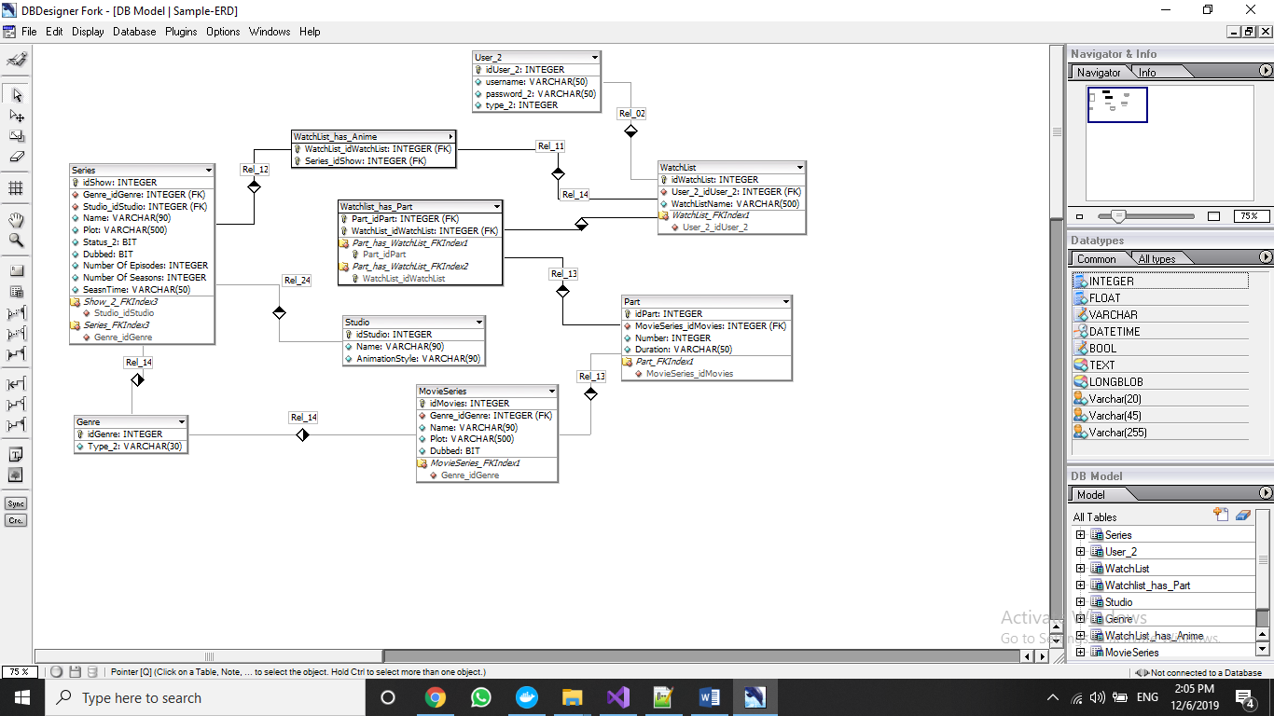

**Design**

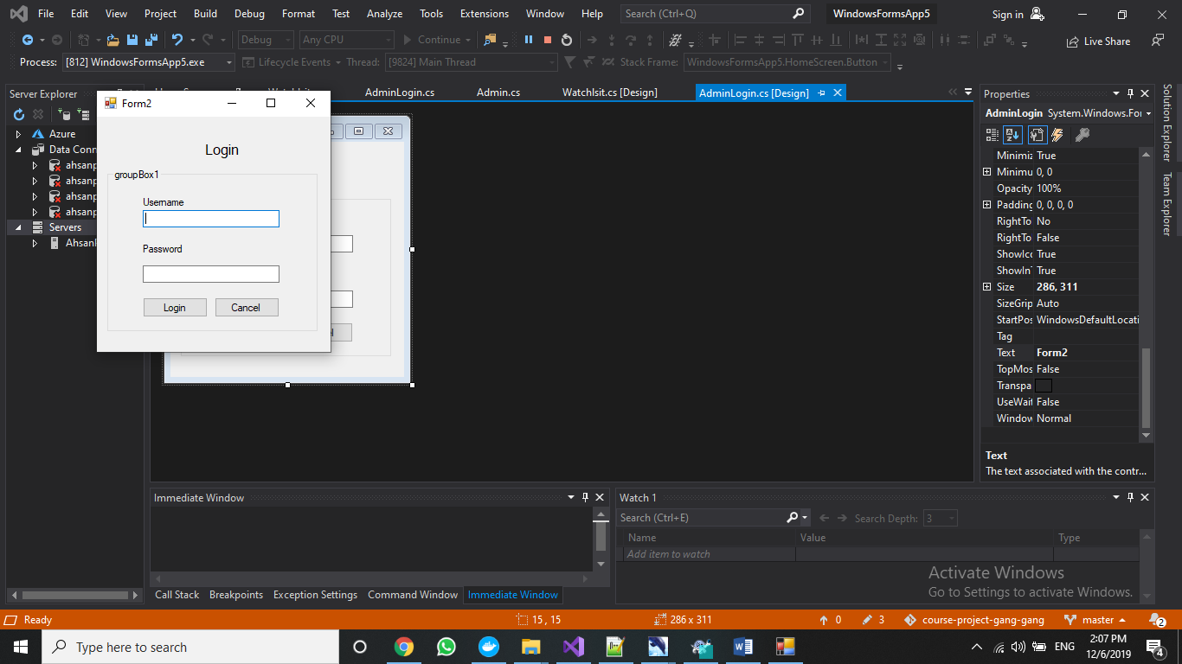

Figure 1: This shows the first screen of the project. A person will be first asked to enter as a user or as an admin

, a person chooses to enter as either an admin or a user, through login.

.

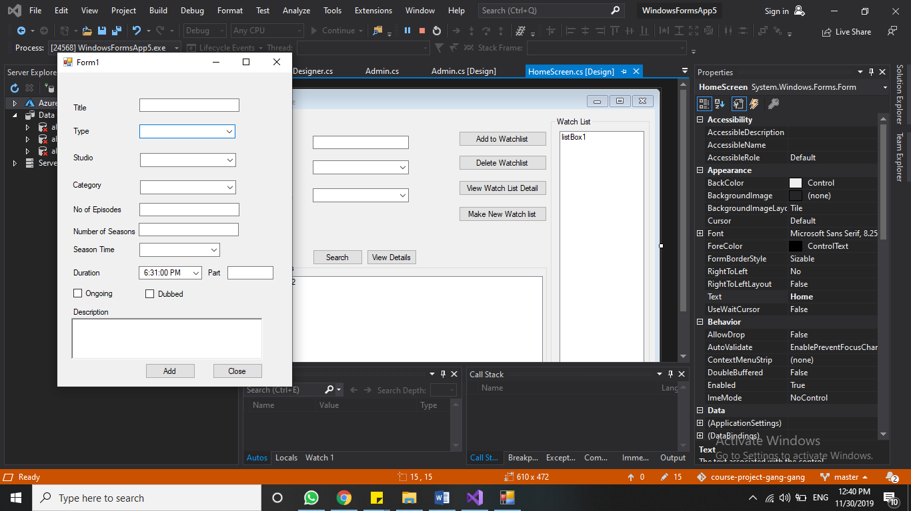

Figure 2: if any person enters as admin and are, able to login then they will be directed to this screen. This screen allows the admin to enter any new content into the database

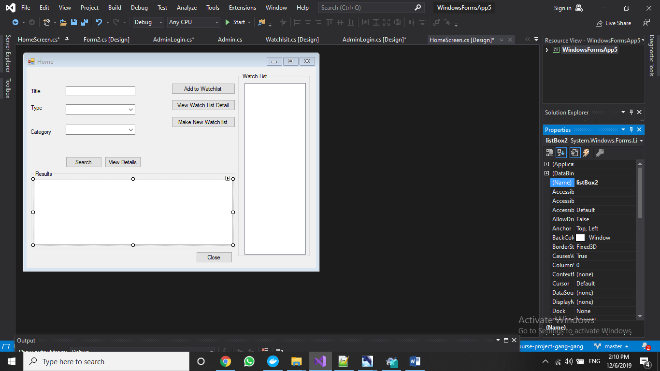

Figure 3: if any person enters as user and is able to log in, they will be directed to this screen. On this user will be able to search any content based on what they want to see and ot will search it up for them and display the title in results box below.They will also be able to see their watchlist, create new watch list, delete entire watch list, add result to watch list and look at the details of watchlist.

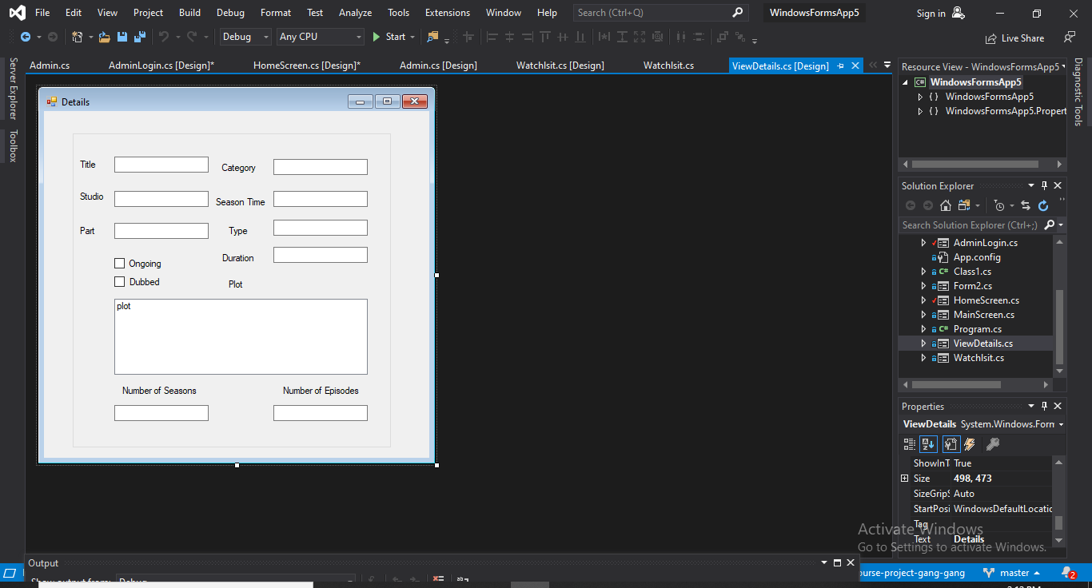

Figure 4 from the result box in search screen, if anyone wants to see more details in the result then they can click on view details of the screen and will be directed here to get more details of the content they selected

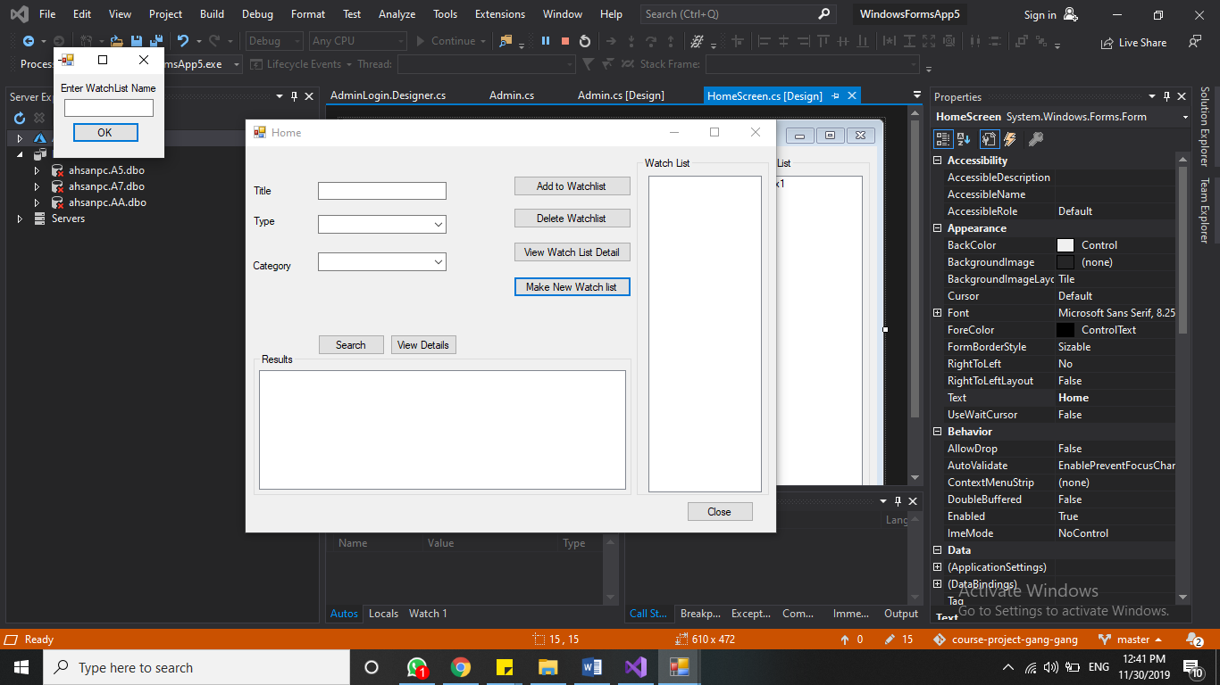

Figure 5 from the search screen if any user wishes to create a watch list then they can through this screen

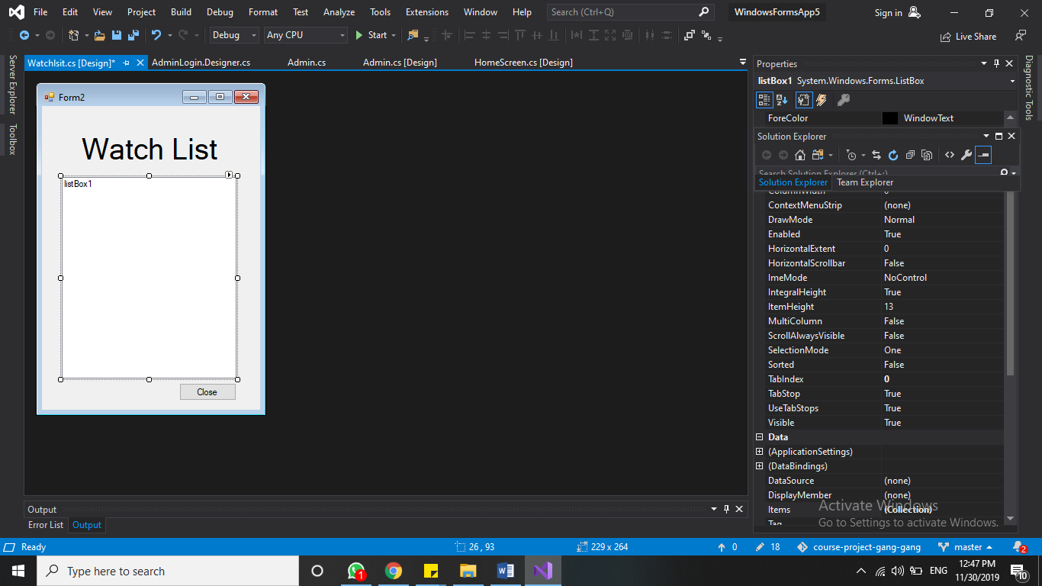

Figure 6 from the user main screen, if anyone wishes to view watchlist then they will be directed to this screen displaying all the names of the content they have added to that specific watchlist

Figure 7 Flowchart of Project

**Implementation**

**Test Cases**

**User/Admin Login Form:**

1.  
input=ahsan,123  
output=Search form opens  
  
2.  
input=ahsdn,123  
output=”Invalid credentials!”

3.  
input=ahsan,1234  
output=”Invalid credentials!

4.  
input=affan,123  
output= Search form opens

5.  
input=affan,123  
output= Search form opens  
  
6.  
input=username empty  
output= “please enter username”

7.  
input=password empty  
output= “please enter password”

**Search form:**  
  
1.  
input=View details without selecting item  
Output=”Please select Item from result”

2.  
input=View watch list details without selecting watch list  
Output=”Please watch list you want to search”

3.  
input=Add to watch list without selecting watch list  
Output=”Please item and watch list that you want to enter”

4.  
input=Add to watch list without selecting item  
Output=”Please item and watch list that you want to enter”

5.  
input=Add to watch list without selecting item and watch list  
Output=”Please item and watch list that you want to enter”

**Watch List from**

1.  
Input=Delete   
Output=”Are you want to delete this?”  
  
**Add form**  
  
1.  
input = empty fields  
output=”Please enter all the fields”

**Conclusion**

We have successfully implemented the content recommended system and have connected it to our database. Through this application, the user is able to look for any content based on their likings and also save them in watch lists for later use. A further step to this work could be to have media files in the database so that it content can also be viewed from the application directly.

**APPENDIX**

**Admin Add Content**

1.1, Insert MovieSeries values((select idGenre from Genre where type_2=" + cat_box.SelectedItem + " )," + Title_box.Text + "," + plot_text.Text + " , " + dubbed_check.Checked + ");";

1.2, Insert into Part values((select idMovies from MovieSeries where name =" + title_box.text + " )," + part_text.Text + "," + duration_text.Text + ");";

2.1, Insert Series values((select idStudio from Studio where Name=" + studio_box.SelectedItem + " ),(select idCategory from SeasonTime where Tpe_2=" + season_box.SelectedItem + " )," + Title_box.Text + "," + plot_text.Text + " , " + dubbed_check.Checked + ");";

**Search for content query**

3.1,

if (typebox.SelectedItem.ToString() == "Movies")

select * from MovieSeries where name like titletext.Text% and Genre_Genreid =(select idGenre from genre where type_2 = catbox.SelectedItem.ToString();

3.2,

if (typebox.SelectedItem.ToString() == "Series")

select * from Series

where name like titletext.Text% and Genre_Genreid =(select idGenre from genre where type_2 ="+catbox.SelectedItem.ToString()

3.3,

select * from Series,MovieSeries

where MovieSeries.name like titletext.Text % and Series.Name like titletext.Text % and Genre_idGenre =(select idGenre from Genre where type_2 = catbox.SelectedItem.ToString()) and

Series.Genre_Genreid = titletext.Text % and Movieseries.Genre_idGenre =(select idGenre from Genre where type_2= catbox.SelectedItem.ToString() ");

**Add/Delete Watch List query**

4.1, Insert into watchlist values (userz, textbox1.text);

4.2,Delete watchlist where User_2_userid2 = userz and name = watchbox.selecteditem.tostring()

**Add content to Watch List**

5.1 insert into watchlist_has_anime values((select idWatchlist from watchlist where user_2iduser = userz and name = watchbox.selecteditem.tostring()),( select idshow from Series where name = result.selecteditem.tostring()[3]))

5.2 insert into watchlist_has_Part values((select idWatchlist from watchlist where user_2iduser = userz and name = watchbox.selecteditem.tostring()),( select Part_idPart from Part where name = result.selecteditem.tostring()[4]) and MovieSeries_MovieID =(select idMovies from MovieSeries where name = result.selecteditem.tostring()[3]))

**View Details of Content**

6.1 Select * from Series where idSeries = resultbox.selecteditem.tostring()[1]

Select * from Part,MovieSeries where Movieseries.Seriesid =Part.Seriesid and Movieeries.name = resultbox.selecteditem.tostring()[3]]